### **Project 10: PIR Motion Sensor**

**Description**

The human body infrared motion sensor can detect infrared signals from moving people or animals, and output switching signals. It can be applied to various occasions to detect human movement. The conventional pyroelectric infrared sensor has a larger volume, a complicated circuit and a lower reliability. Now, we have introduced a human body infrared motion sensor specially designed for Arduino. The sensor integrates an integrated digital pyroelectric infrared sensor and connection pins. It has higher reliability, lower power consumption and simpler peripheral circuits.  
**Specifications:**

* Input voltage: DC 5V
* Working current: 15uA
* Working temperature: -20 ~ 85 degrees Celsius
* Output voltage: high 3 V, low 0 V
* Detection angle: about 140 °
* Detection distance: 3-4 meters
* Pin limit current: 100mA

**Special note：**

* 1. The maximum distance is 4-5 meters during testing.
* 2. When testing, the sensor needs to be covered with white lens, otherwise it will affect the distance.
* 3.Uncover the white cap to see the port label
* 4. The distance is best at 25℃, and the detection distance is shortened when it exceeds 30℃.
* 5. Done powering up and uploading the code, you need to wait 5-10 seconds then start testing, otherwise it is not sensitive.
* 6.Use a screwdriver to adjust the human body induction potentiometer according to the figure below

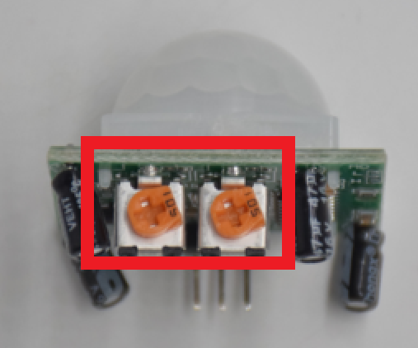

**Equipment：**

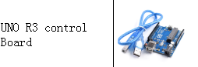

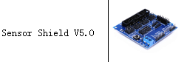

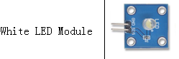

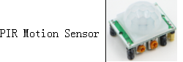

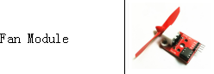

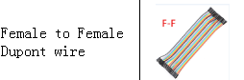**Connection Diagram：**

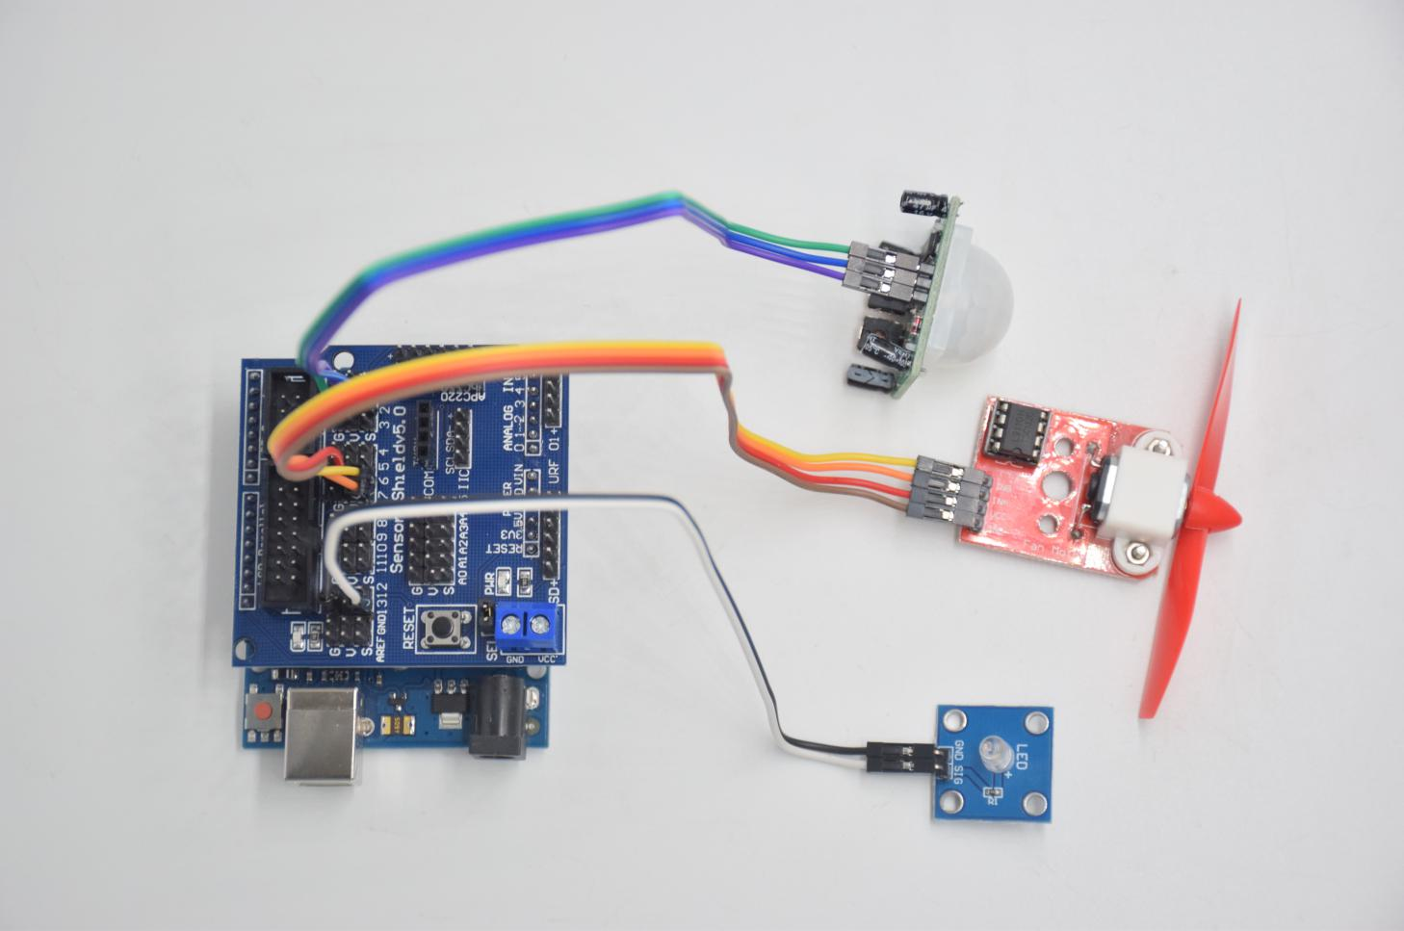

**Human body induction: Motor fan module: LED:**

**GND -- GND INB -- D6 GND -- GND**

**OUT -- D2 INA -- D7 SIG -- D13**

**VCC -- 5V VCC -- 5V**

**GND -- GND**

**Test Code：**

**void setup () {**

**Serial.begin (9600); // open serial port, and set baud rate at 9600bps**

**pinMode (2, INPUT); // Define PIR as input in D2**

**Serial.begin (9600);**

**pinMode (13, OUTPUT); // Define LED as output in D13**

**pinMode (7, OUTPUT); // Define D7 as output**

**pinMode (6, OUTPUT); // Define D6 as output**

**}**

**void loop () {**

**Serial.println (digitalRead (2));**

**delay (500); // Delay 500ms**

**if (digitalRead (2) == 1) // If someone is detected walking**

**{**

**digitalWrite (13, HIGH); // LED light is on**

**digitalWrite (7, HIGH);**

**analogWrite (6,150); // Fan rotates**

**} else // If no person is detected walking**

**{**

**digitalWrite (13, LOW); // LED light is not on**

**digitalWrite (7, LOW);**

**analogWrite (6,0); // The fan does not rotate**

**}}**

**Test Result：**

**Upload the test code, open the serial monitor, and set the baud rate to 9600. If the human infrared sensor detects people around, the serial monitor displays "1", D13 and the white LED indicator light up at the same time, and the fan rotates. If there is no one around, the serial monitor displays "0" and the D13 indicator and white LED are off. The fan stopped spinning.**